Docker Fundamentals: Get the Most Out of Docker

Evening Webinar <https://www.youtube.com/watch?v=t2aKpgYErsk> 9:00 starts

<https://www.docker.com/resources/docker-fundamentals-get-the-most-out-of-docker-webinar/?key=b63243cd84809f3c93524364de9271f8cab390533abc98a9a4e6e3ad2cce2c54&utm_campaign=2023-12-14-wb-on-demand-confirm&utm_medium=email&utm_source=marketo>

Morning Webinar

[Docker Fundamentals: Get the Most Out of Docker | Docker](https://www.docker.com/resources/docker-fundamentals-get-the-most-out-of-docker-webinar/?key=b63243cd84809f3c93524364de9271f8cab390533abc98a9a4e6e3ad2cce2c54&utm_campaign=2023-12-14-wb-on-demand-confirm&utm_medium=email&utm_source=marketo)

<https://github.com/mikesir87/docker-starter>

$ mkdir docker-starter  
$ cd docker-starter  
$ git clone https://github.com/mikesir87/docker-starter.git

Rename

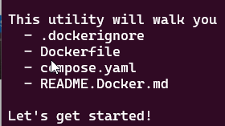

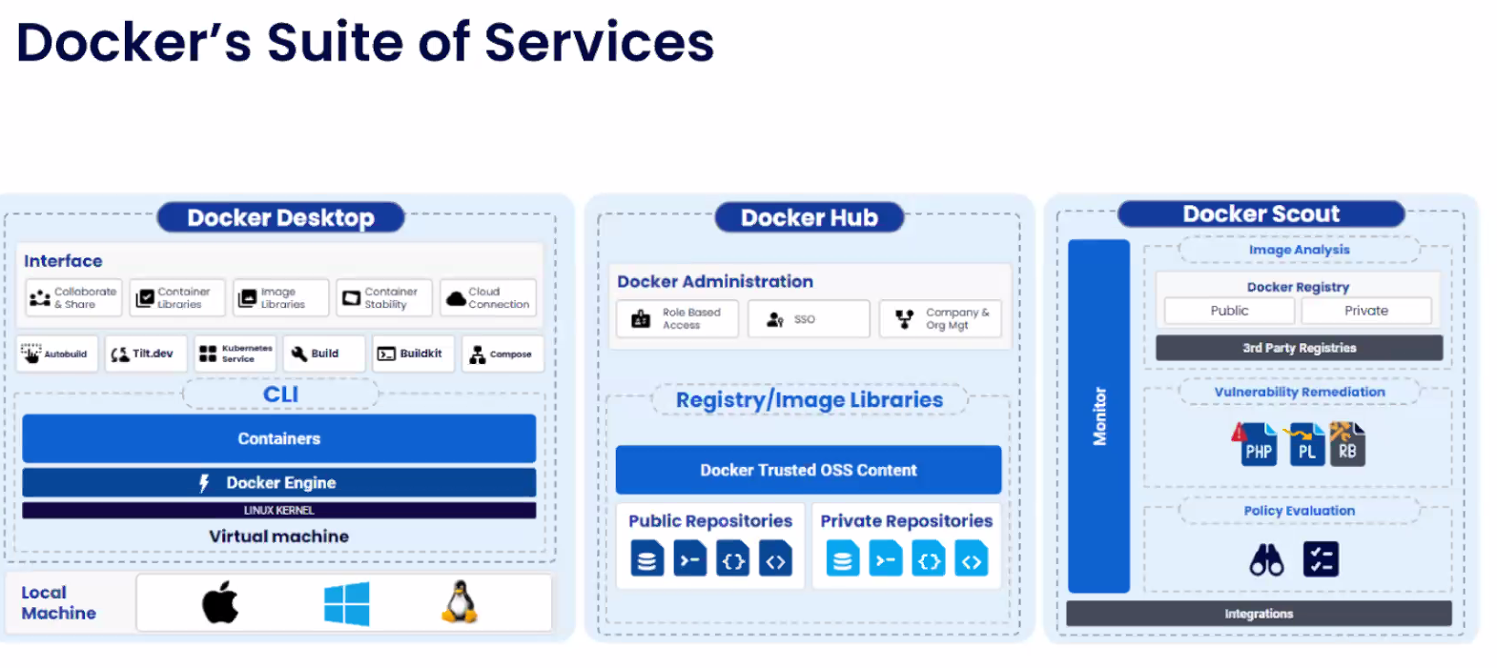  
Container is an isolated process in your machine 30:10

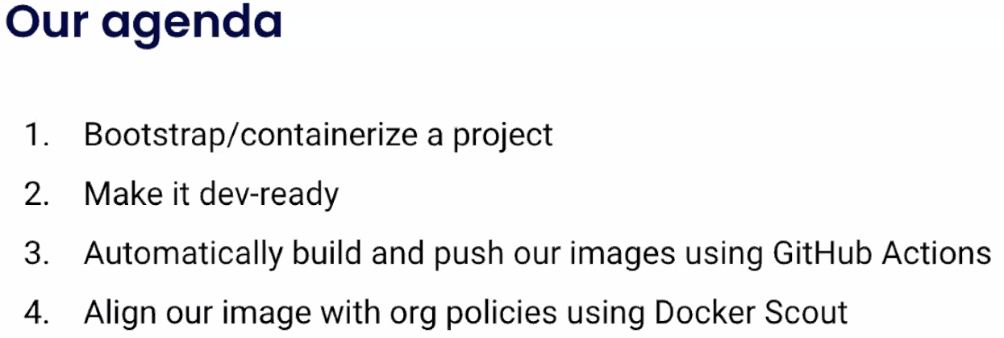

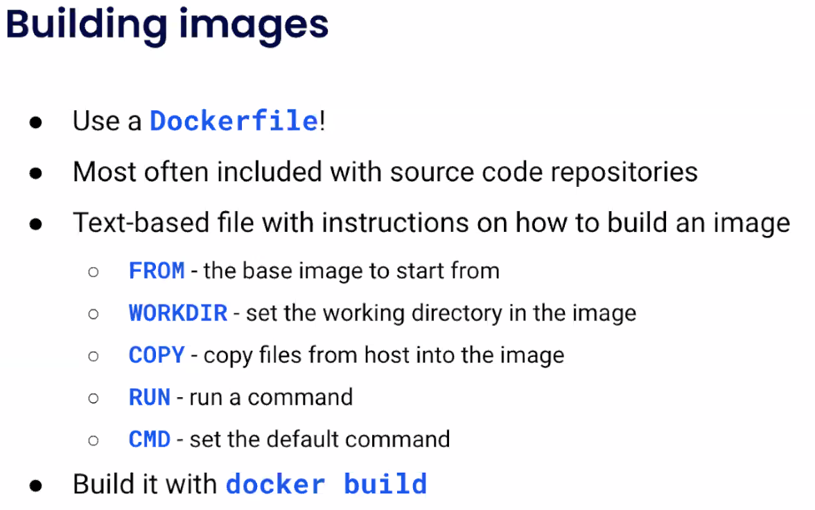

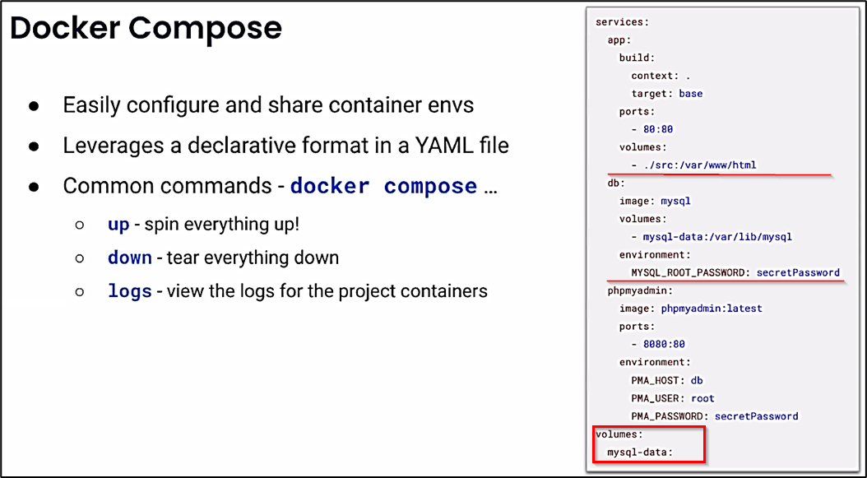

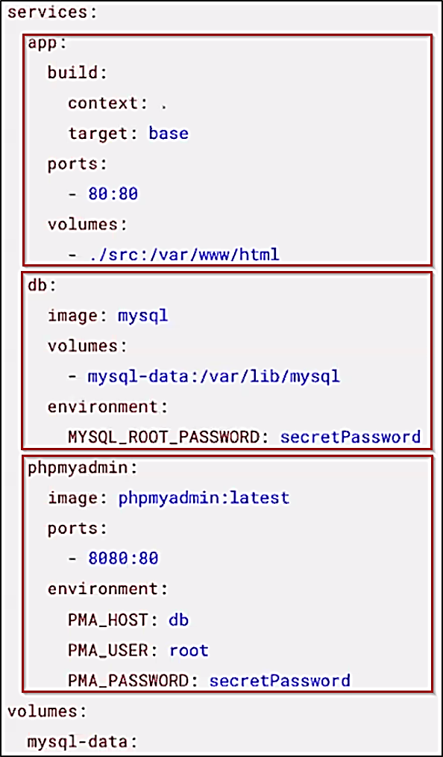

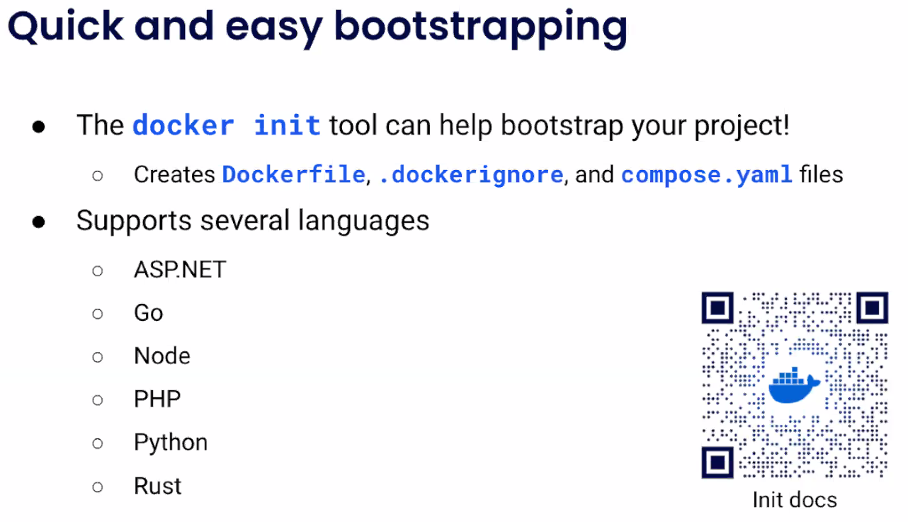

https://docs.docker.com/engine/reference/commandline/init/

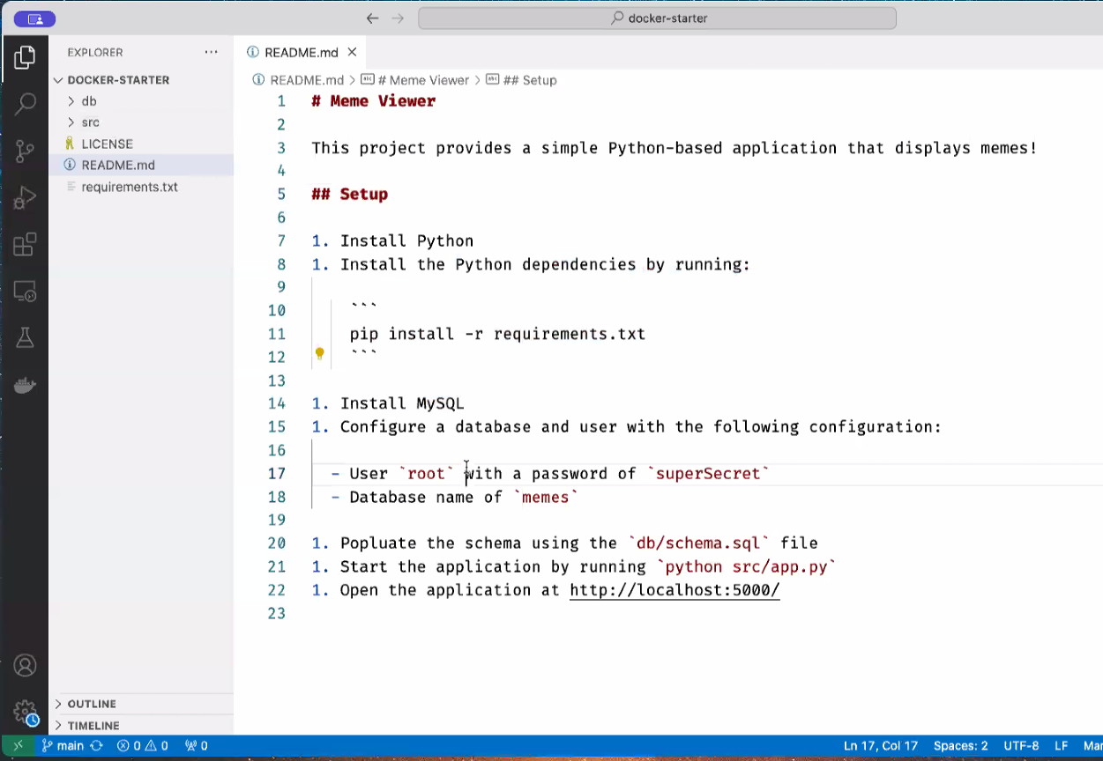

# Meme Viewer ReadMe.md

This project provides a simple Python-based application that displays memes!

## Setup

l. Install Python

1. Install the Python dependencies by running:

```

pip install -r requirements. txt

```

1. Install MySQL

1. Configure a database and user with the following configuration:

- User `root` with a password of `superSecret`

- Database name of `memes`

1. Popluate the schema using the `db/schema.sql` file

1. Start the application by running `python src/app.py`

1. Open the application at <http://localhost:5000/>

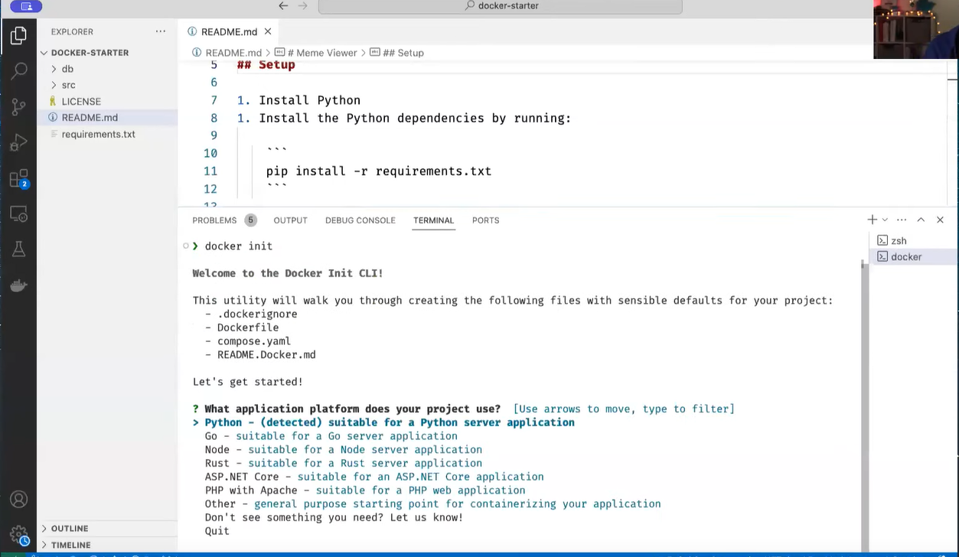

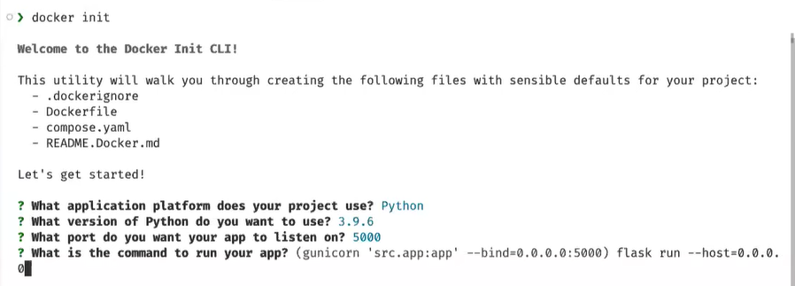

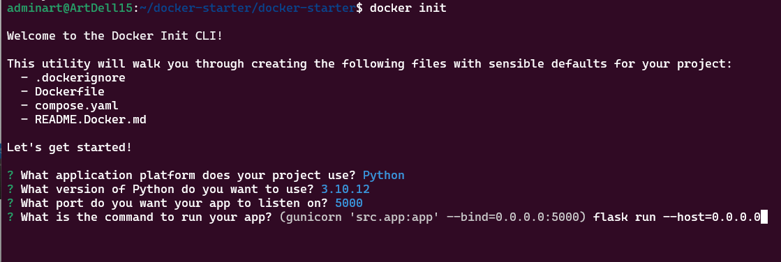

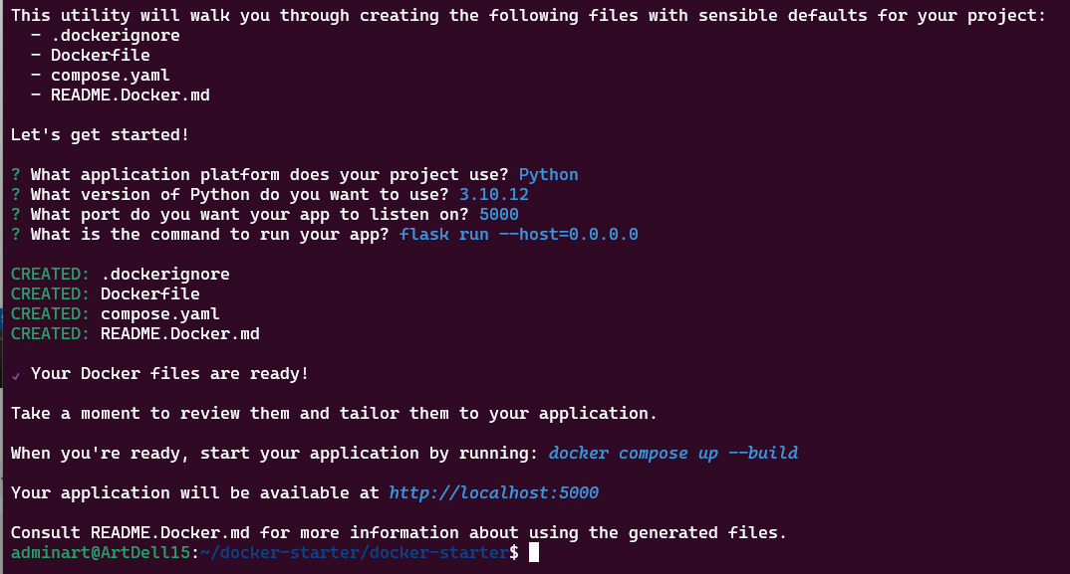

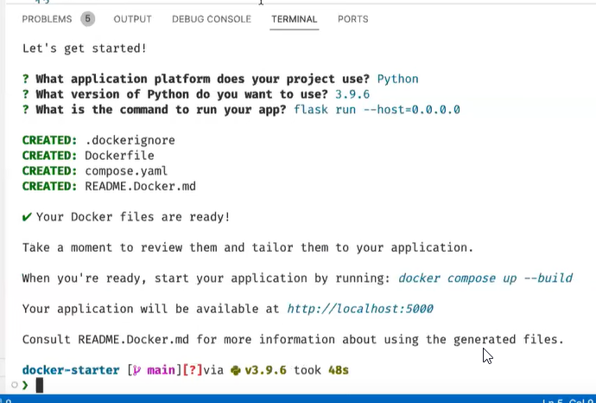

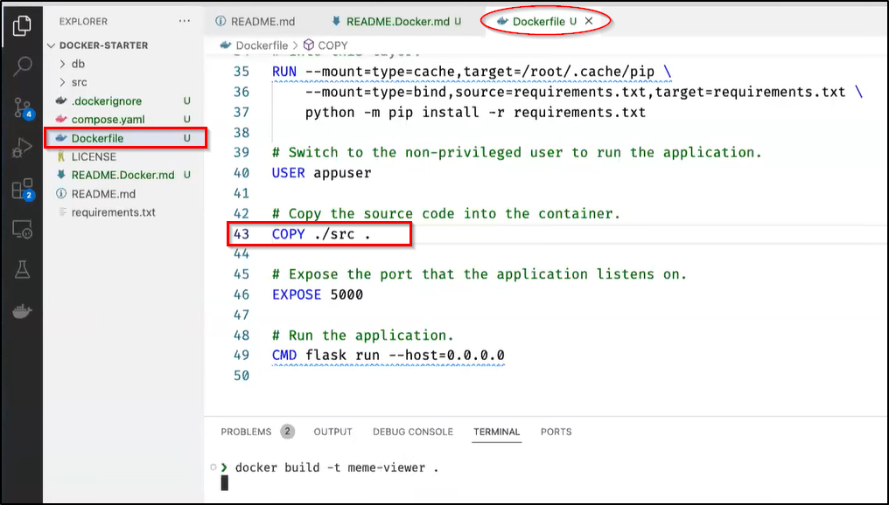

$ docker build -t meme-viewer .

$ docker images  
$ docker image ls  
# this will create an unusable container because the missing

Modify compose.yaml, add database and shared volume

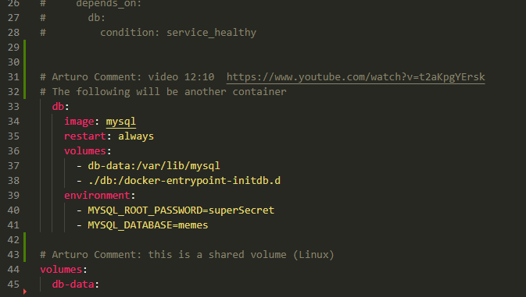

# Arturo Comment: video 12:10 https://www.youtube.com/watch?v=t2aKpgYErsk

# The following will be another container

db:

image: mysql

restart: always

volumes:

- db-data:/var/lib/mysql

- ./db:/docker-entrypoint-initdb.d

environment:

- MYSQL_ROOT_PASSWORD=superSecret

- MYSQL_DATABASE=memes

# Arturo Comment: this is a shared volume (Linux)

volumes:

db-data:

Video <https://www.youtube.com/watch?v=t2aKpgYErsk> 12:44 12/19/2023

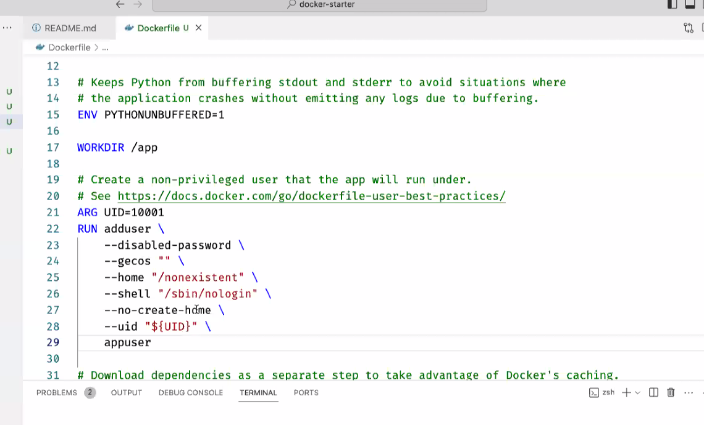

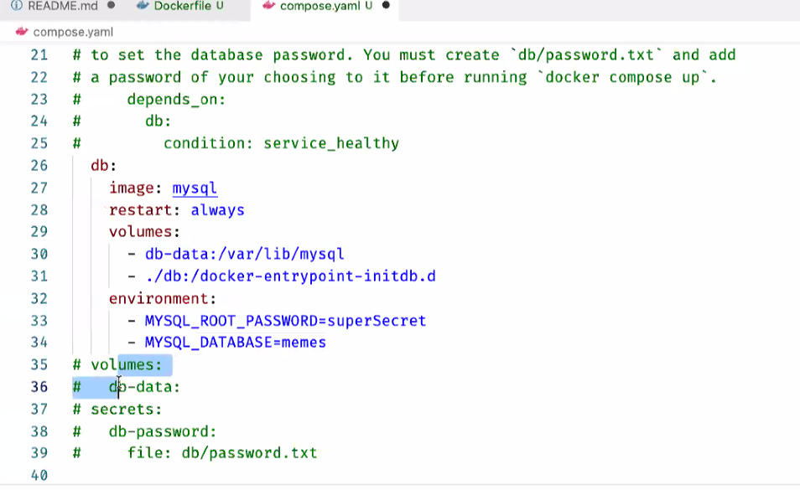

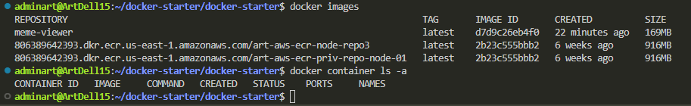

docker compose up

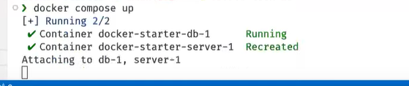

it will recreate

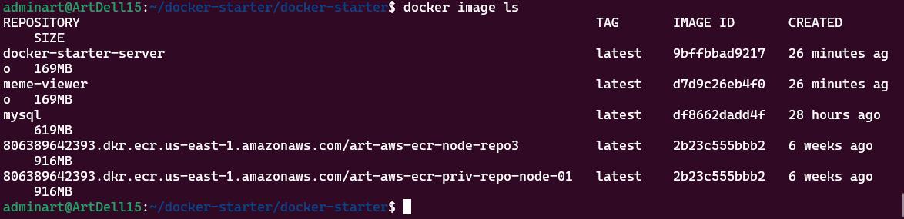

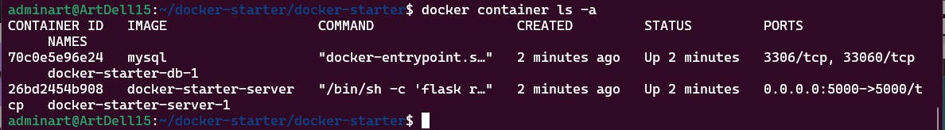

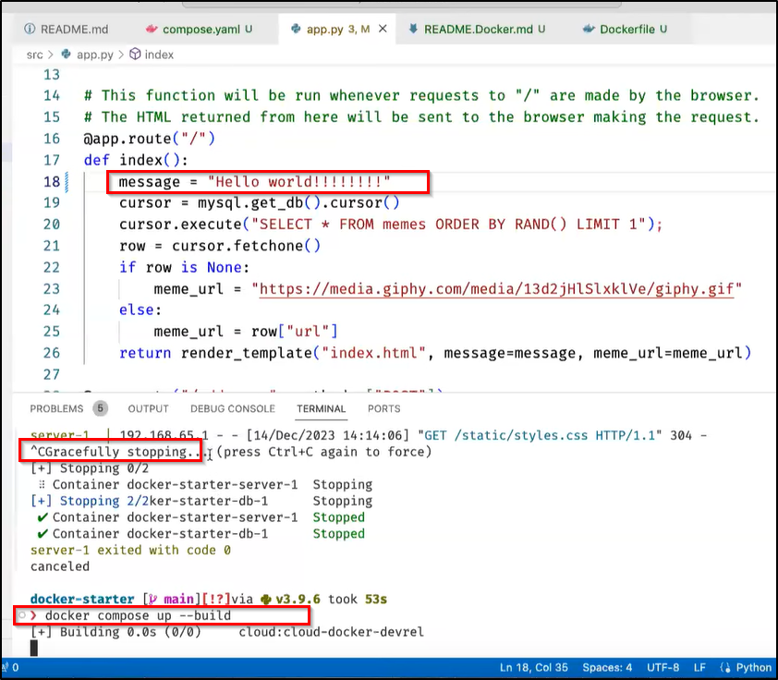

$ docker compose up --build  
$ docker compose up --help  
 --build Build images before starting containers.  
 -d, --detach Detached mode: Run containers in the background  
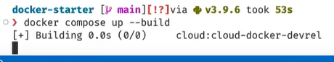

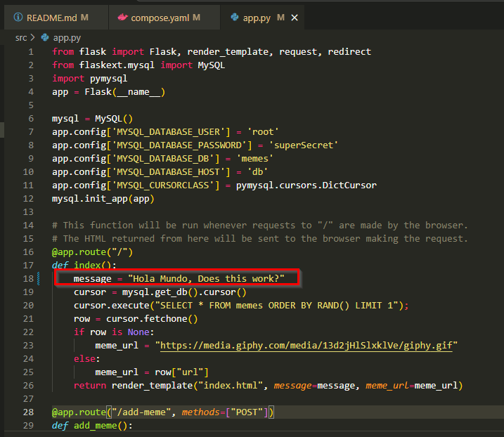

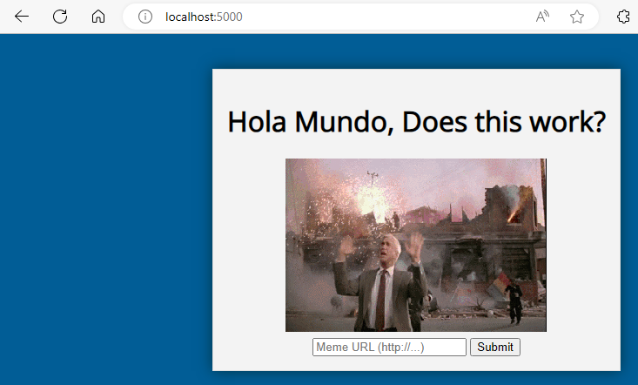

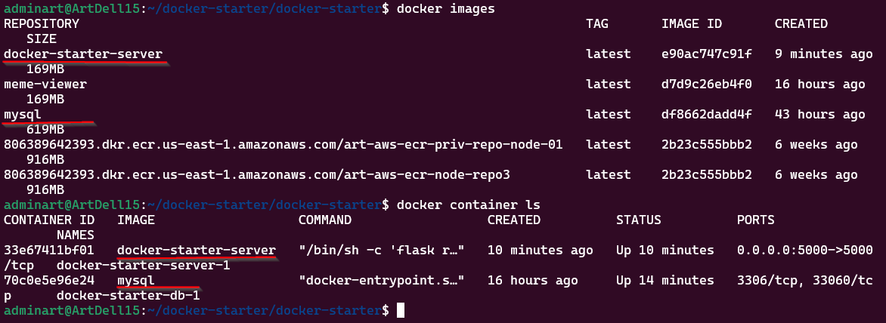

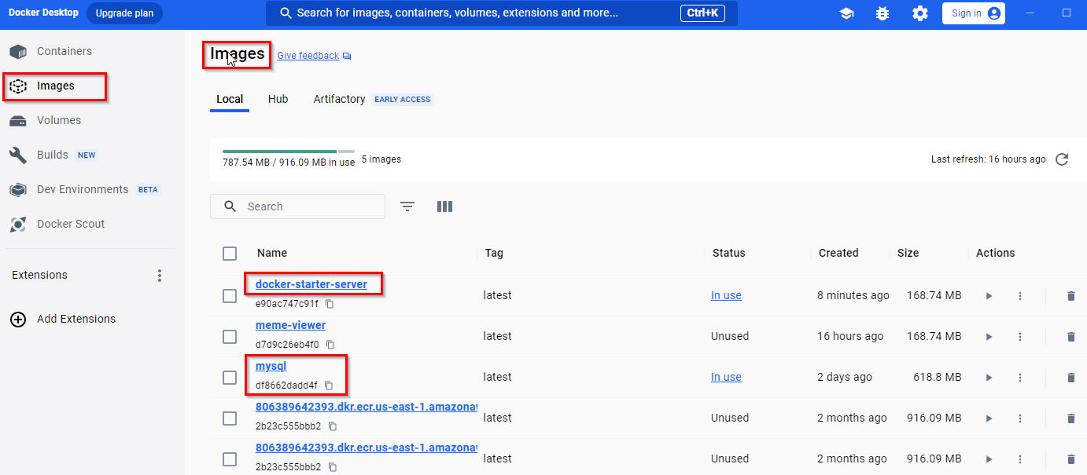

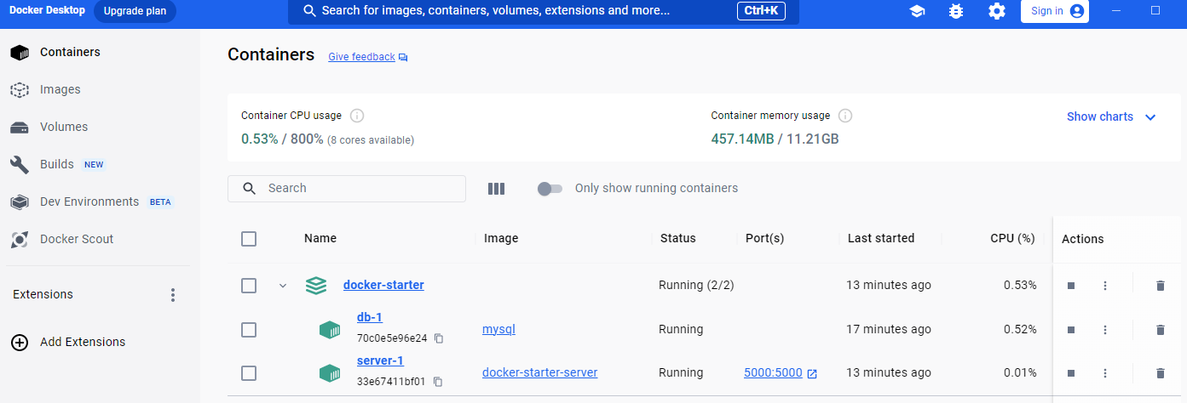

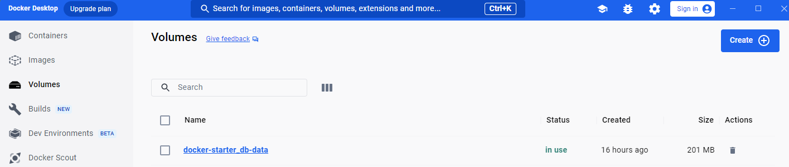

If you want to run the container in the background use –-d to

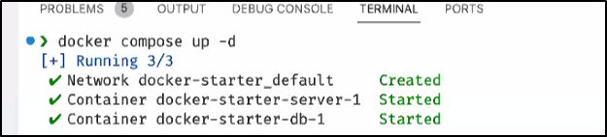

Shared Volumes

Video <https://www.youtube.com/watch?v=t2aKpgYErsk> 15:39 12/20/2023

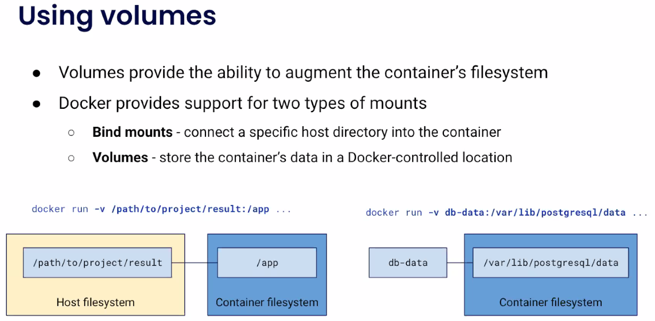

-v, --volume list Bind mount a volume

--volume-driver string Optional volume driver for the container

--volumes-from list Mount volumes from the specified container(s)

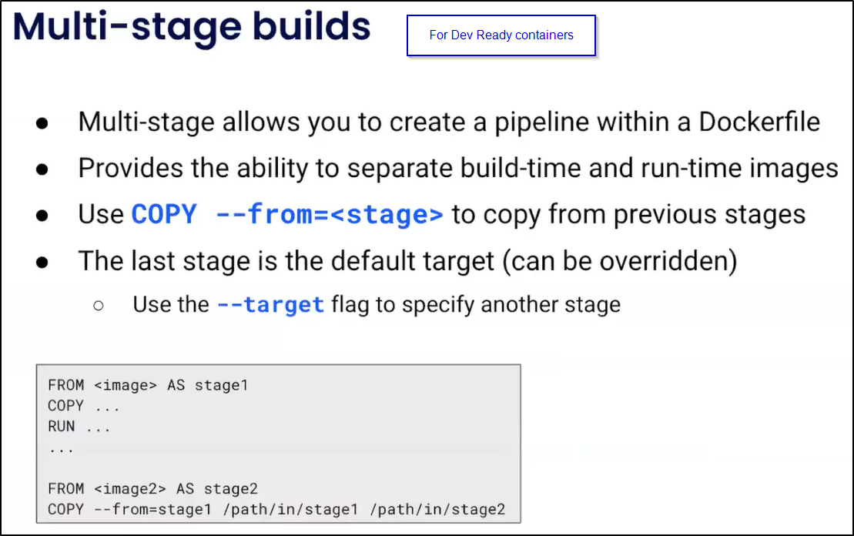

Update Dockerfile

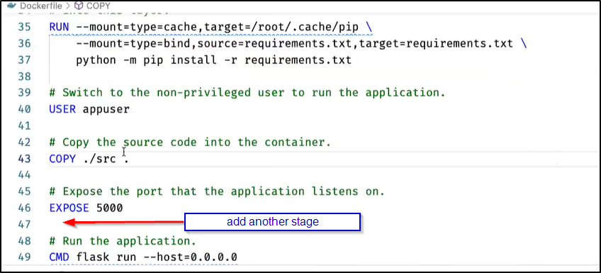

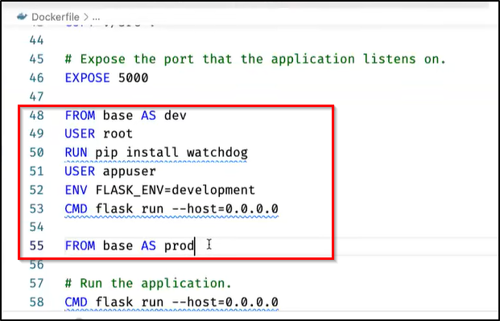

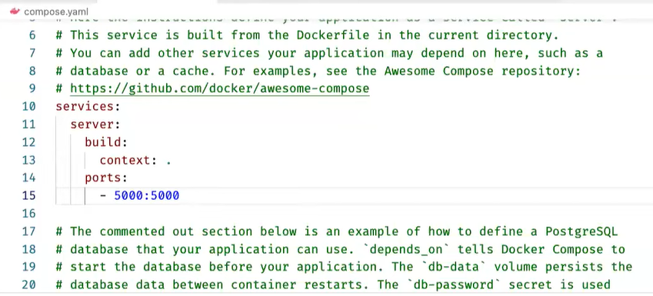

Build the image against that Dev stage and share my source code

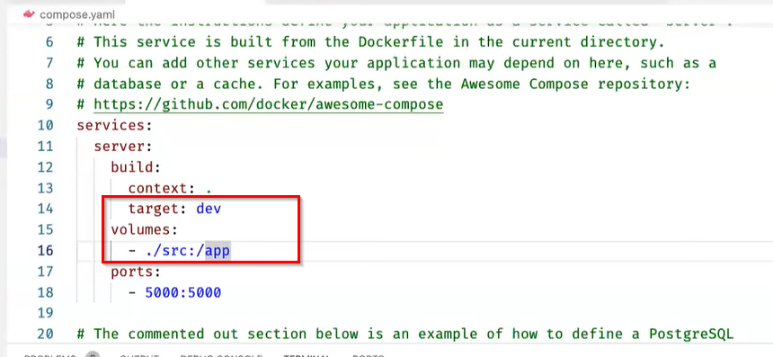

$ docker compose up –-build  
$ docker compose up –-help  
 --build Build images before starting containers.  
 -d, --detach Detached mode: Run containers in the background

Docker Github actions <https://www.youtube.com/watch?v=t2aKpgYErsk> 18:57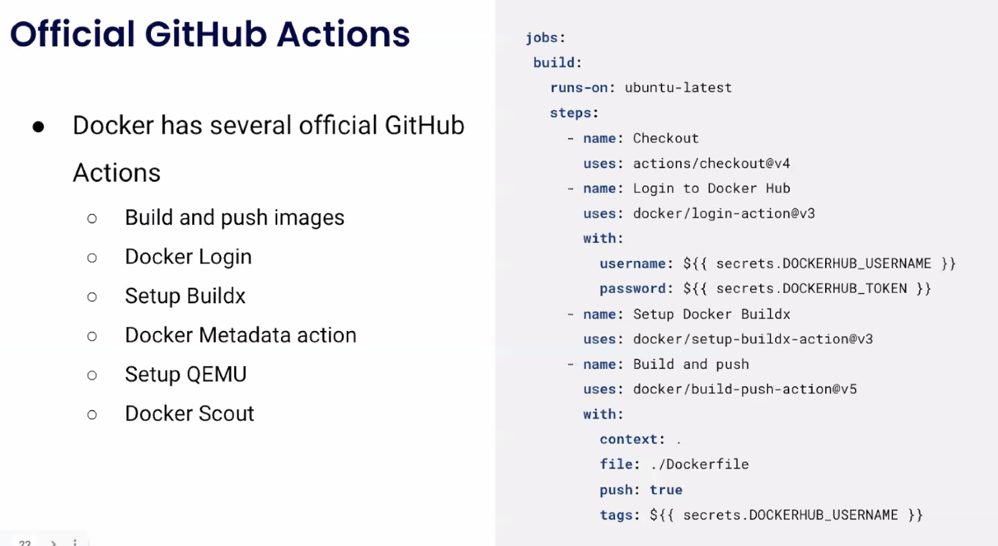

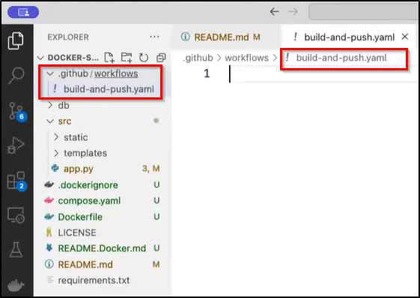

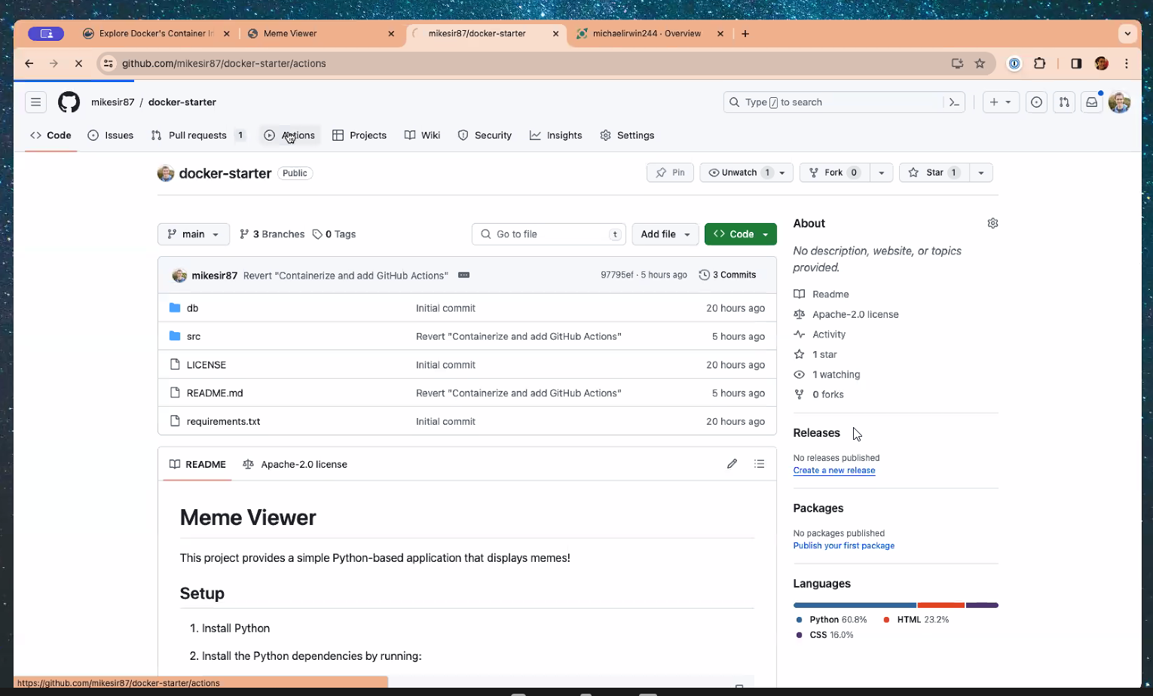

Docker Scout <https://www.youtube.com/watch?v=t2aKpgYErsk> 22:06

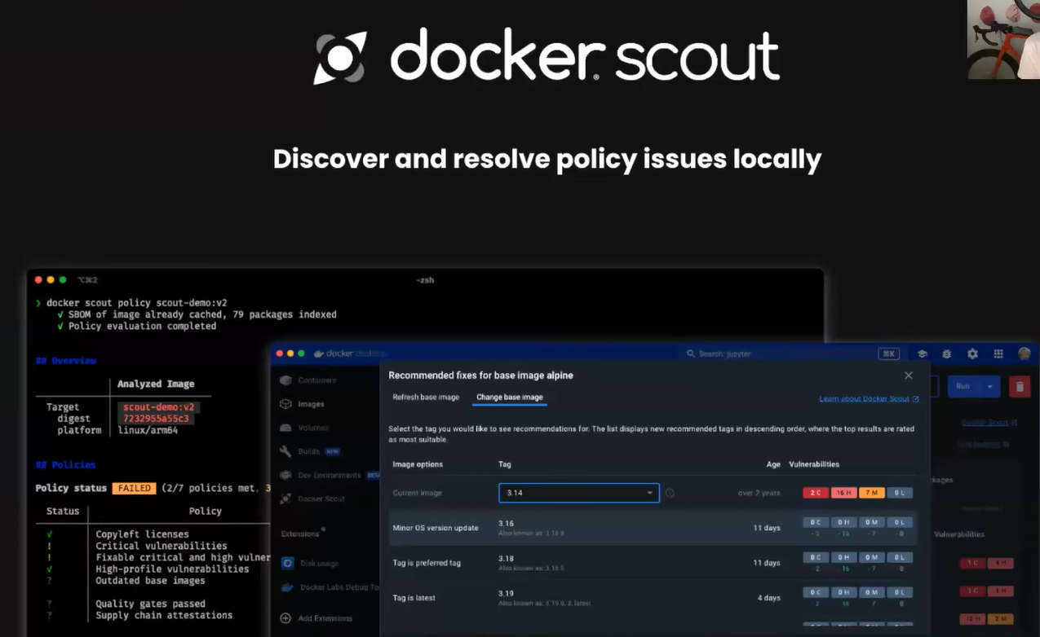

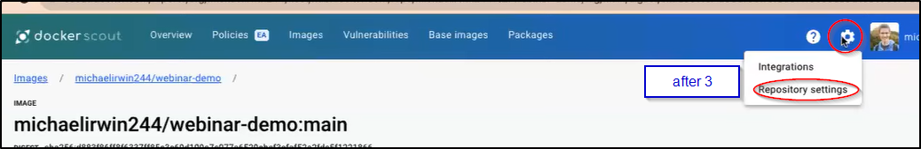

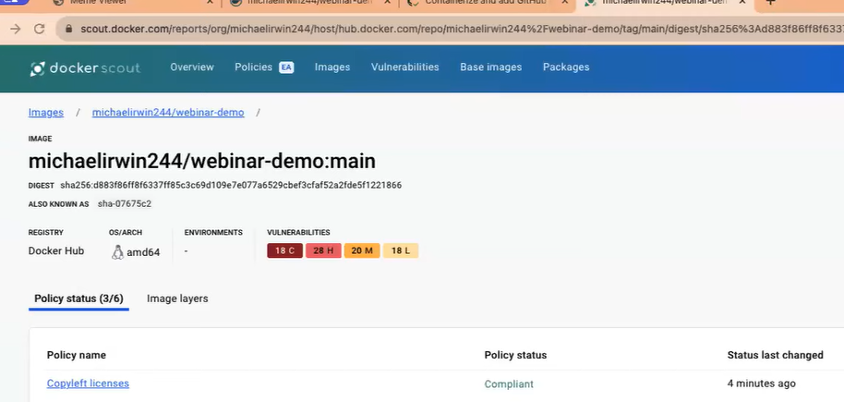

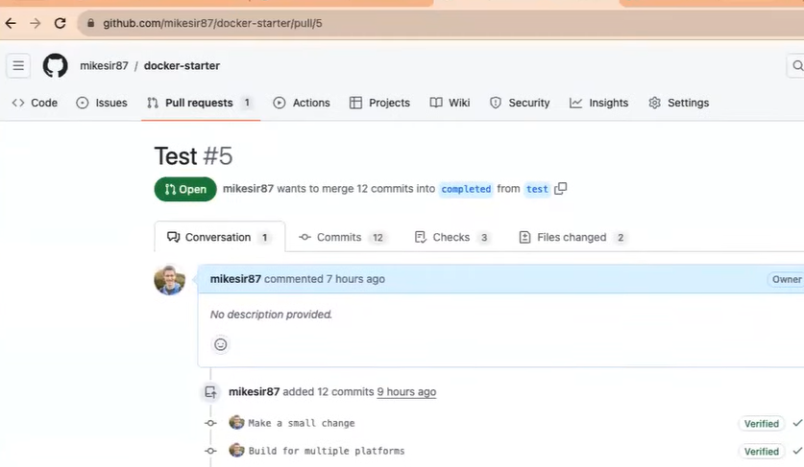

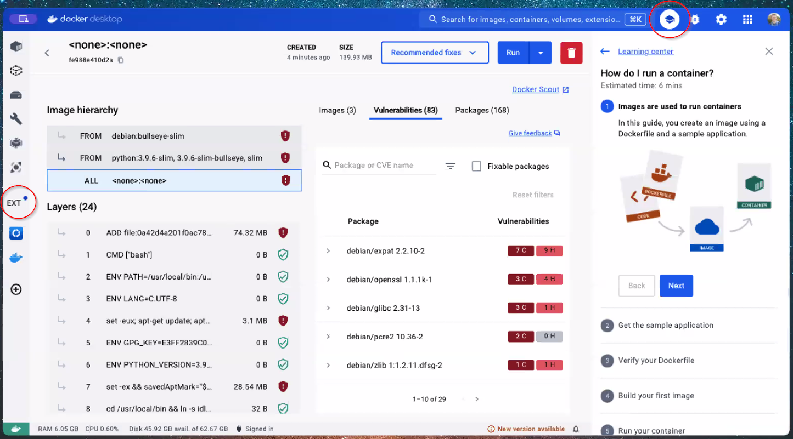

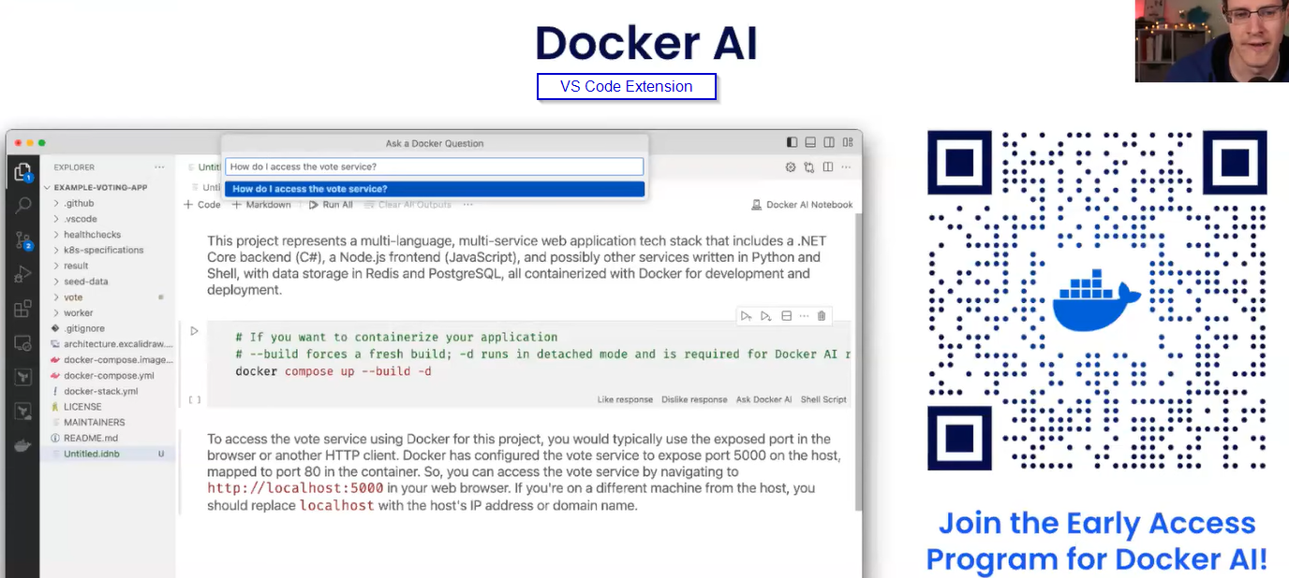  
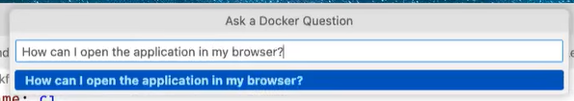  
it will use the context of your machine local folder

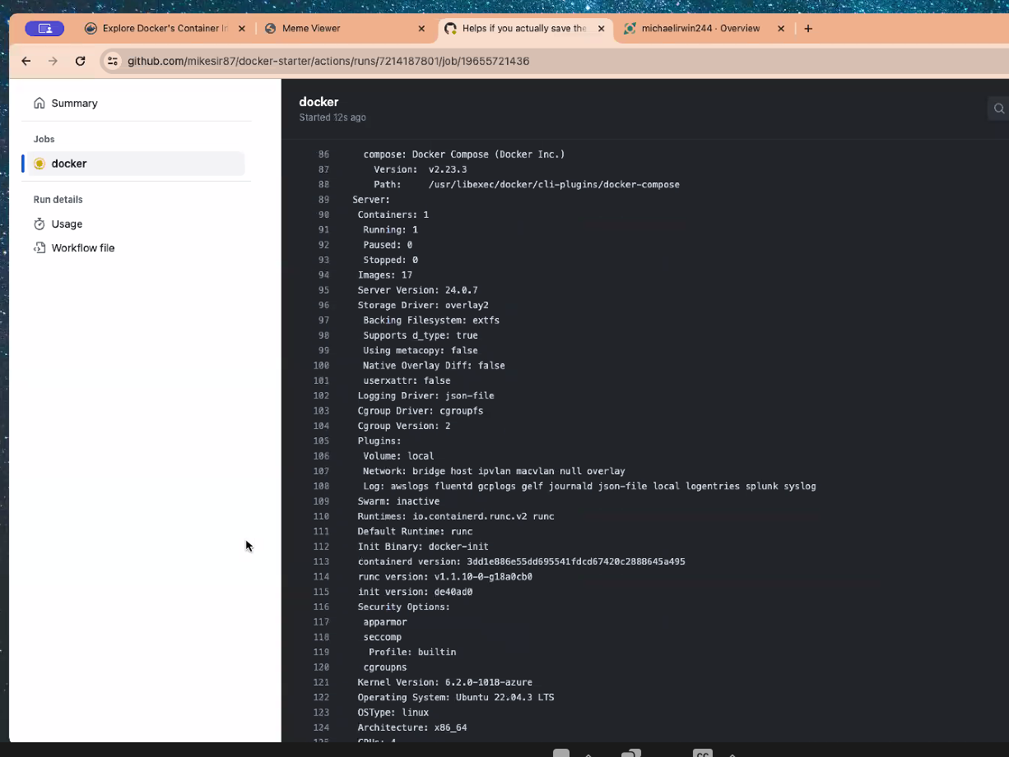

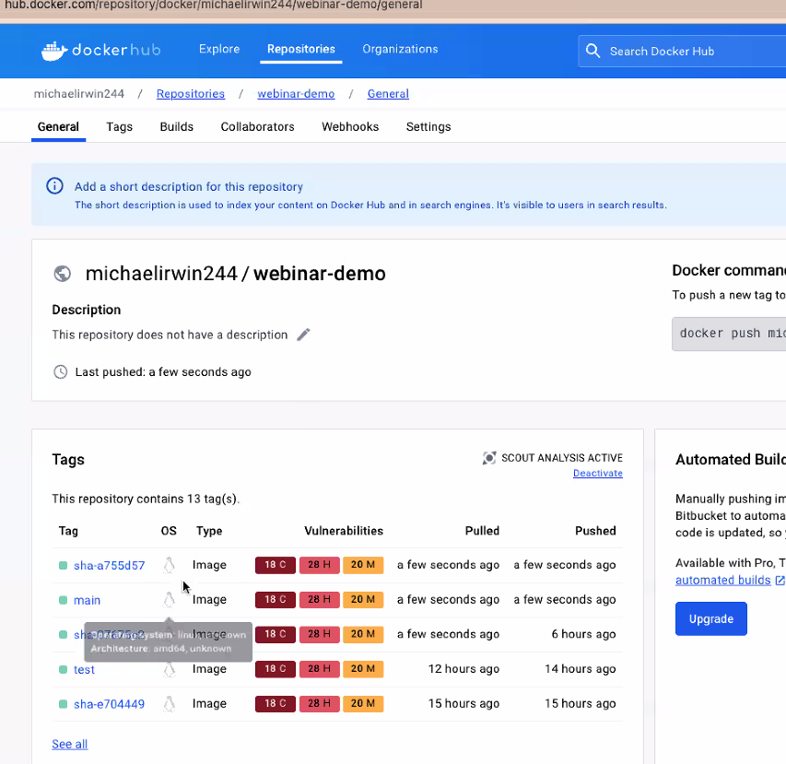

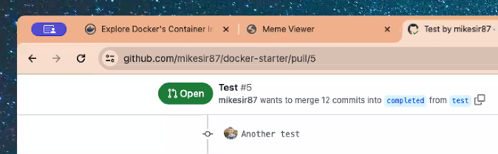

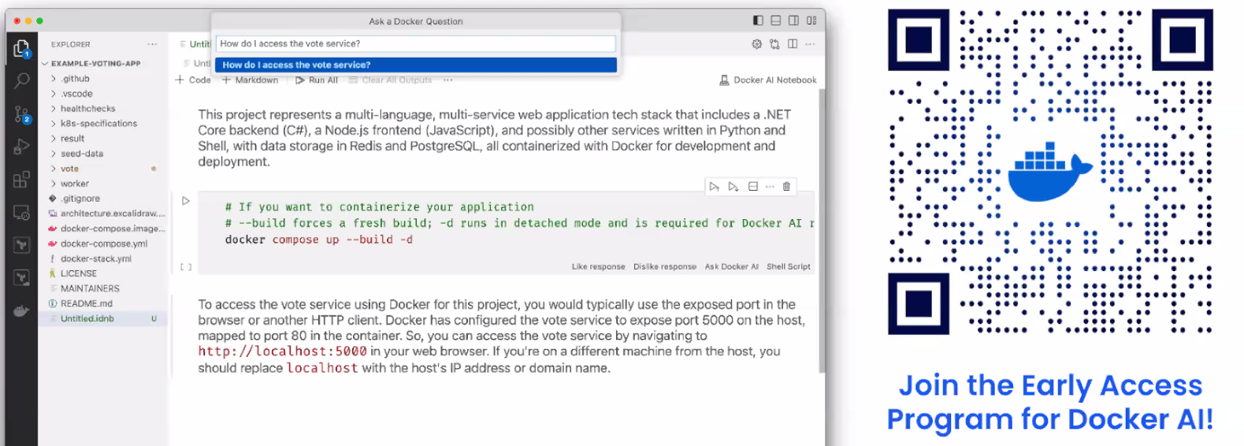

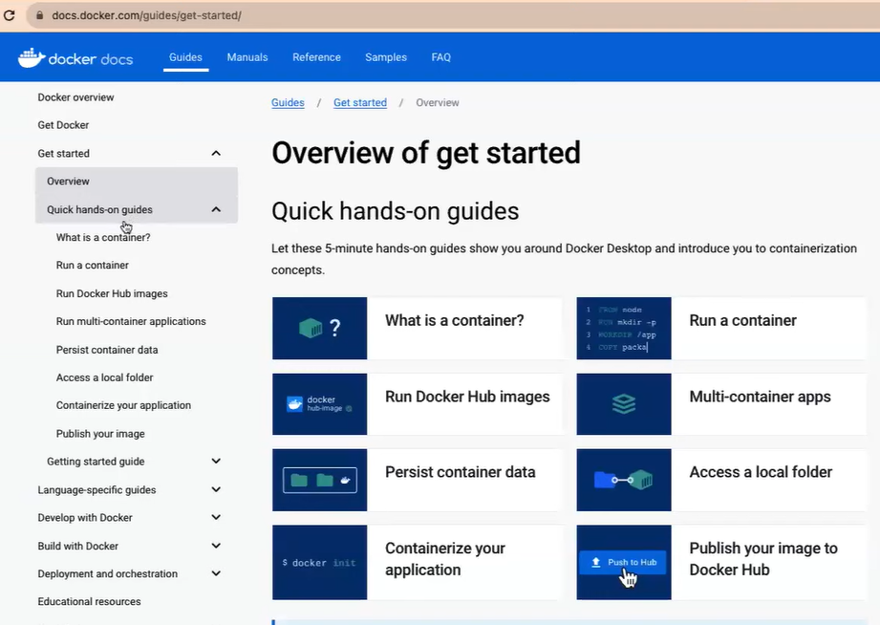

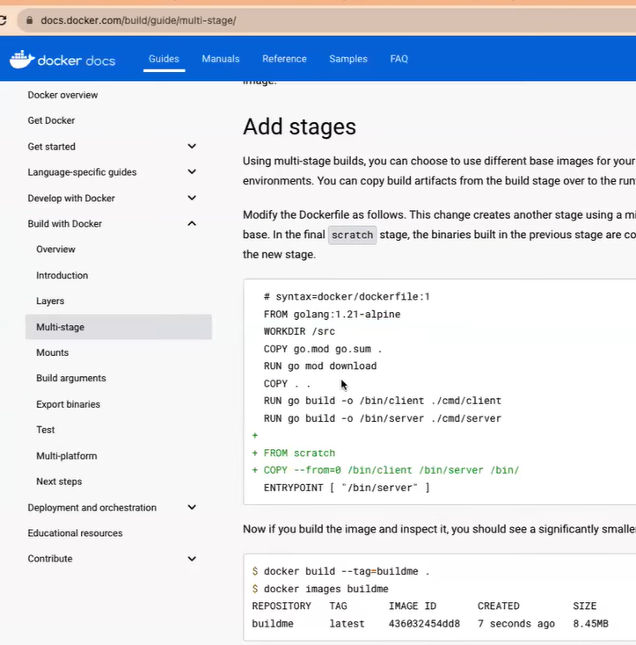

Christian Dupuis (cd) 03:02 PM

Yes, we’ll share the recording after the seesion.

Anonymous Attendee 03:01 PM

Will you be able to record this session and share the recording with the attendees?

Christian Dupuis (cd) 03:02 PM

Yes, we’ll share the recording after the seesion.

Samuel Alegria 03:05 PM

How long is the webinar?

Christian Dupuis (cd) 03:06 PM

We are trying to land at around 30-35mins.

Anonymous Attendee 03:08 PM

would I receive recorded lnk?

Christian Dupuis (cd) 03:08 PM

Yes, we’ll share the recording after the seesion.

Anonymous Attendee 03:08 PM

Will this session go over docker swarm?

Christian Dupuis (cd) 03:09 PM

No, we won’t be convering docker swarm.

Eswaran Palanisamy 03:08 PM

were can we get the step by step guide, from ground zero.

Christian Dupuis (cd) 03:09 PM

A good starting point are our getting started guides at https://docs.docker.com/get-started/.

Saravanan Kaliamurthy 03:10 PM

Would you explain how the container image filesystem works?

Christian Dupuis (cd) 03:12 PM

Thanks for the question. This topic is a bit too advanced for this webinar. But you can read some details over at https://docs.docker.com/storage/storagedriver/overlayfs-driver/#how-the-overlay2-driver-works.

Buland Malik 03:11 PM

Surpriused that Java is not supported

Christian Dupuis (cd) 03:12 PM

Thanks. The team is working on Java support. Stay tuned. Coming soon I hear.

Ajmal Rasouli 03:13 PM

Will be there recording for this?

Christian Dupuis (cd) 03:16 PM

Yes, we’ll share the recording after the seesion.

ram perumalla 03:13 PM

please share the recorded version for this session, joined late by 12 minutes due to sign-in issues!

Christian Dupuis (cd) 03:15 PM

Yes, we’ll share the recording after the seesion.

Evan Miller 03:14 PM

Is this docker-starter repo you're demoing available on GitHub?

This question has been answered live

Christian Dupuis (cd) 03:16 PM

It is. Take a look at https://github.com/mikesir87/docker-starter.

Francisco Pena 03:14 PM

just a comment... really appreciate for having this sessions! keep up the great work!

Christian Dupuis (cd) 03:16 PM

Thank you, appreciate this!

Art Cardenas (You) 03:15 PM

can we get copy of the final code and all project files from this presentation?

Christian Dupuis (cd) 03:18 PM

Yes, take a look at https://github.com/mikesir87/docker-starter and checkout the ‘completed’ branch.

Fidel Palma 03:15 PM

It's usual to run databases on containers? What about the info that you need to keep? What happens when that container no longer exists?

Christian Dupuis (cd) 03:18 PM

That’s where volume mounts become really useful: https://docs.docker.com/storage/volumes/

Guy-Francis Kono 03:15 PM

Do we have access to the repo with this Docker example?

If so, can you please share the link to it?

Christian Dupuis (cd) 03:17 PM

Sure, Michael is working off of https://github.com/mikesir87/docker-starter.

Anonymous Attendee 03:21 PM

This webinar didn’t allow zoomgov users to login. Just FYI

Christian Dupuis (cd) 03:22 PM

Thank you. I’ll forward this to the right people. Sorry for any inconcience caused.